|  |
| --- |
| <div id="dining"><img src="/img/edward-franklin-Nb_Q-M3Cdzg-unsplash Burger and Beer 2 6 22.jpg" width="200px" |
|  | height="200px" alt="image of burger and beer"></div> <br><br><br><br><br><br><br><br>The Race House |
|  | showcases |
|  | the beauty of classic exhibitions throuhout the grounds, |
|  | <div id="classcar"><img src="img/automobile-gfed46634e_1920 museum car 2 2 22.jpg" width="200px" height="200px" |
|  | alt="image of classic cars"></div> |
|  | <br><br>an arcade gaming room with arcade racing games,<div id="arcade"><img |
|  | src="img/wilmer-martinez-zLlXblupecM-unsplash arcade1 2 7 22.jpg" width="200px" height="200px" |
|  | alt="image of arcade and young girl"></div> <br>kart racing <div id="kartcar"><img |
|  | src="img/bastien-plu-CUt2SVsDbk4-unsplash kart racer2 2 6 22.jpg" width="200px" height="200px" |
|  | alt="image of kart car racing"></div><br><br>and luxury lodging <div id="lodging"><img |
|  | src="/img/gideonputnam-putnam-suite-2-lg.jpg" width="200px" height="200px" alt="image of lodgings"> |
|  | </div> |
|  | </p> |
|  | </div> |
|  | <br> |
|  | <br> |
|  | <div id="abair"> |
|  |  |
|  | <div><img src="/img/ABSTRACTED AIR BY LYN HINER.png" width="950px" height="950px" |
|  | alt="Image of painting called the Abstracted Air by Lyn Hiner"></div> |
|  | </div><br> |
|  |  |
|  | </body> |
|  |  |
|  | </html> |

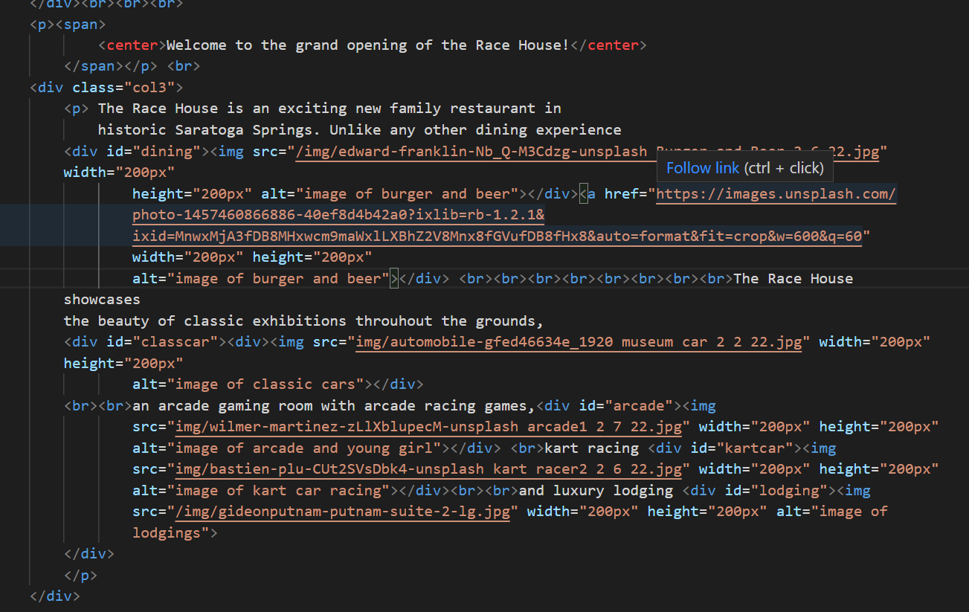

<a href="https://images.unsplash.com/photo-1457460866886-40ef8d4b42a0?ixlib=rb-1.2.1&ixid=MnwxMjA3fDB8MHxwcm9maWxlLXBhZ2V8Mnx8fGVufDB8fHx8&auto=format&fit=crop&w=600&q=60" width="200px" height="200px"

            alt="image of burger and beer"></div>

 flex-direction: column;

            justify-content: center;

            justify-items: center;

            justify-content: space-around;

            justify-content:space-between;

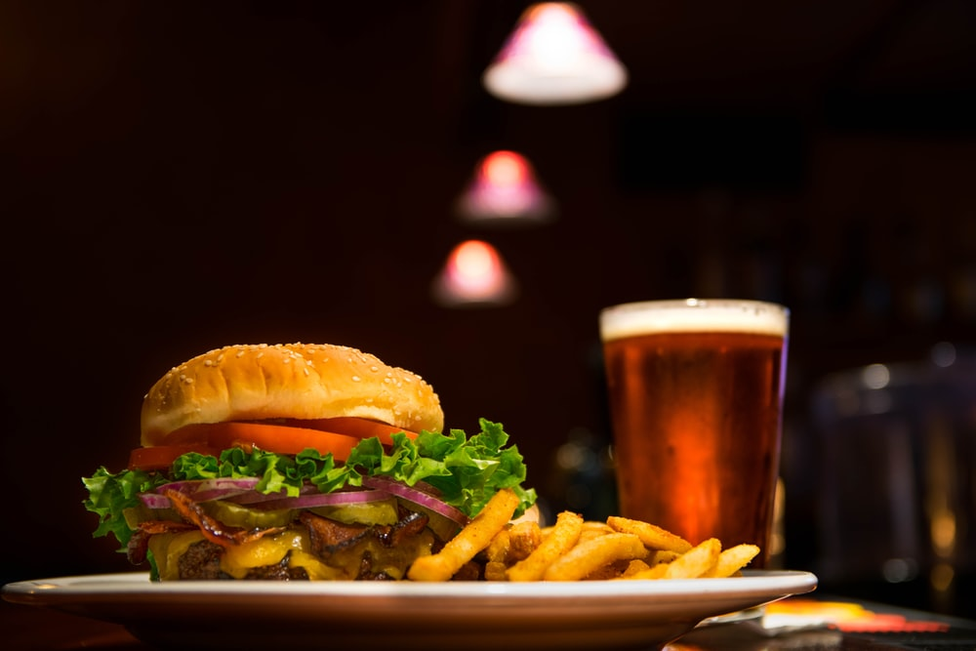

https://images.unsplash.com/photo-1457460866886-40ef8d4b42a0?ixlib=rb-1.2.1&ixid=MnwxMjA3fDB8MHxzZWFyY2h8MXx8YnVyZ2VyJTIwYW5kJTIwYmVlcnxlbnwwfHwwfHw%3D&auto=format&fit=crop&w=600&q=60

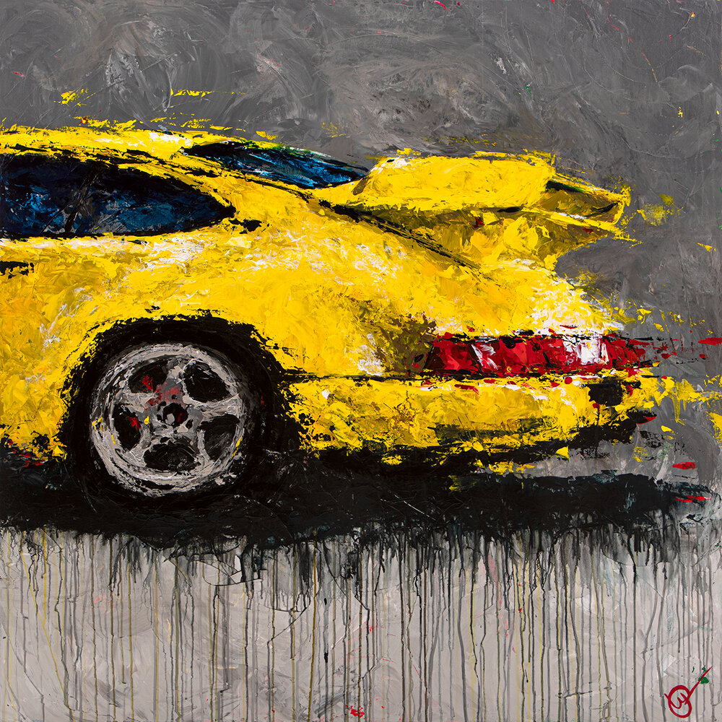

<https://images.squarespace-cdn.com/content/v1/521f4119e4b0609085e5ab68/1620663421383-2AEATXVVE47IEM03ADWP/Abstracted+Air_2_web1350.jpg?format=1000w>

<a href=”<https://images.squarespace-cdn.com/content/v1/521f4119e4b0609085e5ab68/1620663421383-2AEATXVVE47IEM03ADWP/Abstracted+Air_2_web1350.jpg?format=1000w>” width=”800px” height=”800px” alt=”Image of Painting called the Abstracted Air#2 by Lyn Hiner”>

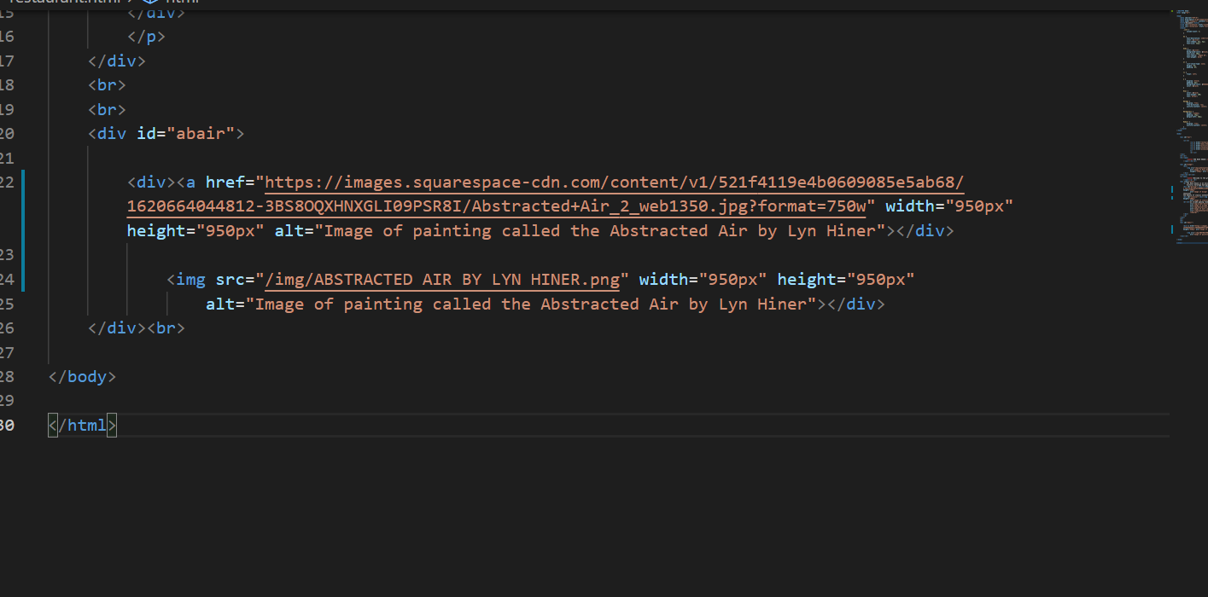



<https://images.unsplash.com/photo-1457460866886-40ef8d4b42a0?ixlib=rb-1.2.1&ixid=MnwxMjA3fDB8MHxzZWFyY2h8MXx8YnVyZ2VyJTIwYW5kJTIwYmVlcnxlbnwwfHwwfHw%3D&auto=format&fit=crop&w=600&q=60>

<div id="abair">

           <p><div><a href=”https://images.squarespace-cdn.com/content/v1/521f4119e4b0609085e5ab68/1620663421383-2AEATXVVE47IEM03ADWP/Abstracted+Air_2_web1350.jpg?format=1000w” width=”800px” height=”800px” alt=”Image of Painting called the Abstracted Air #2 by Lyn Hiner”></div>

        </div></p><br>